ADP Registration for PayStubs and W2s
Rev. 4/2018

In order to gain access to ADP, you will be prompted to complete a short registration process during which you must enter contact and security information, answer a few security questions and create a password. Your password must be at least eight characters long and must contain at least one letter and either one number or one special character. Also, your password is case sensitive.

You will be assigned a system generated User ID ending in @DaemenCol. The security questions will be used to verify your identity if you ever forget your user ID or password.

Note: If you ever get “locked out” of the ADP system, please contact the HR/Payroll Office at 716-839-8325 or hr@daemen.edu; we will reset your password- which will send you a temporary password to login and create a new one.

Steps to Register:

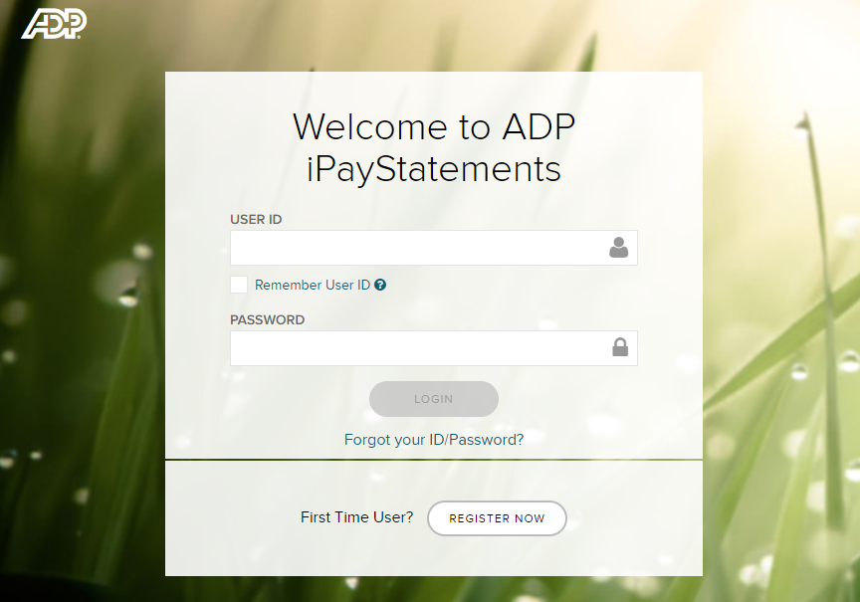
- You may start your registration process immediately at https://ipay.adp.com, by clicking the “Register Now” link.

- Your Registration Pass Code: DaemenCol-Pays is required for registration.
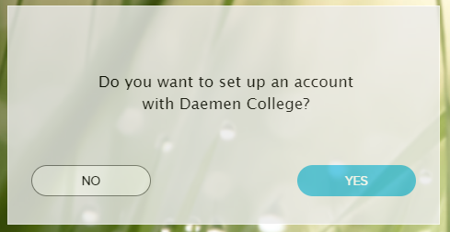
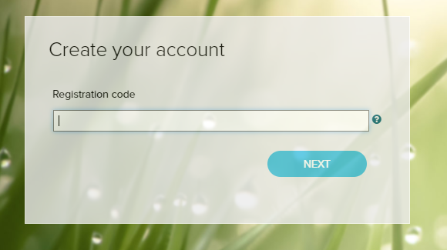

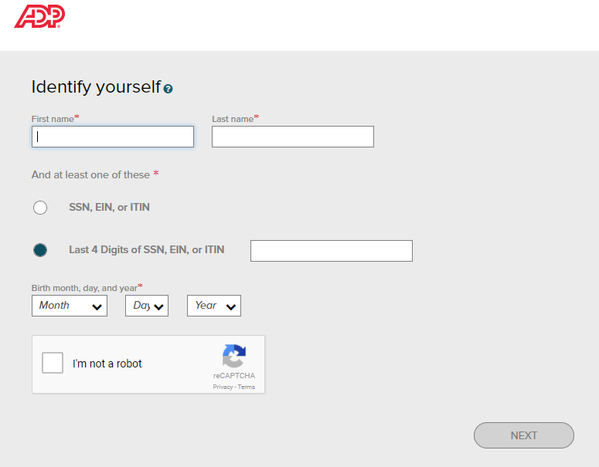

- Upon completing the registration process, you may access your pay statements at https://workforcenow.adp.com/. You will be able to see your paystubs after your first direct deposit is processed through our Payroll and your W2s at the end of the year.
